Office of the Prime Minister’s Chief Science Advisor
Kaitohutohu Mātanga Pūtaiao Matua ki te Pirimia

Fluoridation: Figures
Updated May 2021

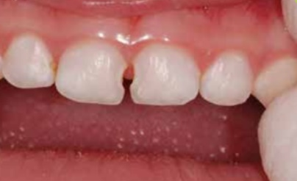
Figure 1 Example of tooth decay in front teeth of upper jaw (primary teeth). Credit: Phantumvanit P. Source: WHO

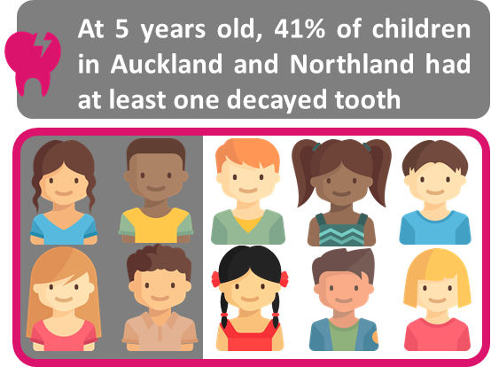
Figure 2 Dental decay in five-year olds in Auckland and Northland. Data from Aung et al. (2019)

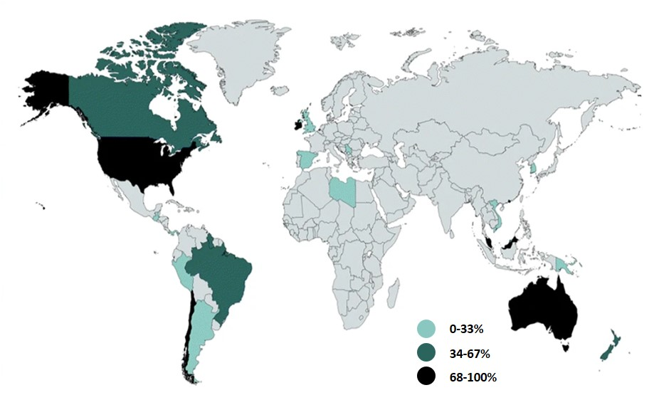Figure 3 Proportion of the population given government-regulated fluoridated water (light teal 0–33%, teal 34–67%, black 68–100% of population). From Johnston and Strobel (2020)

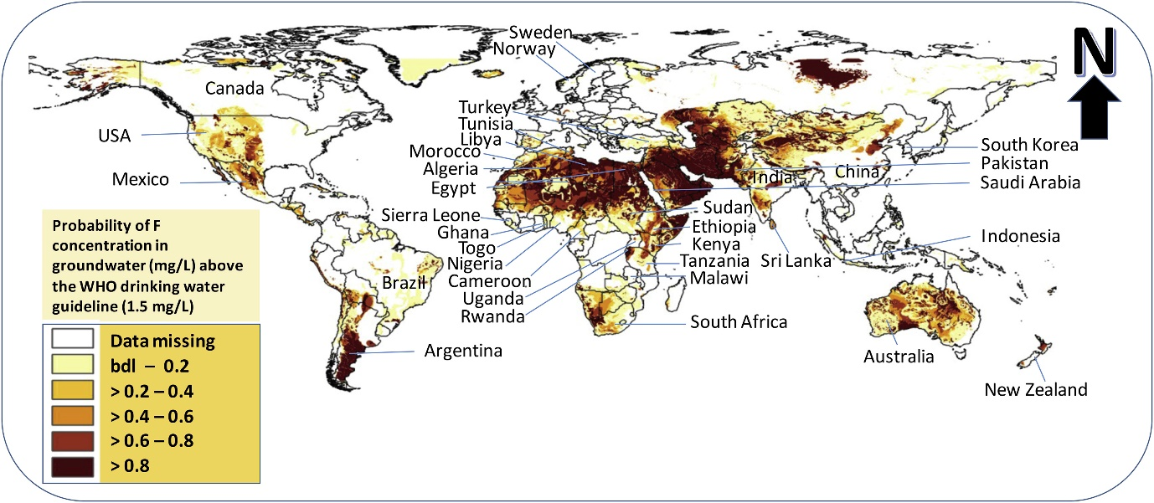
Figure 4 Map showing the occurrence and distribution of fluoride in groundwater in different parts of the world. From Kimambo et al. (2019)

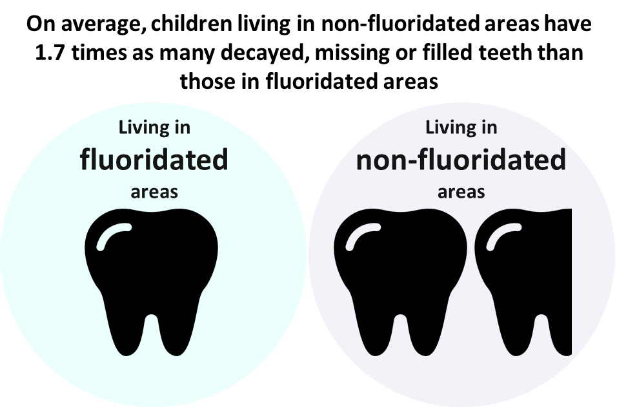
Figure 5 The adjusted ratio of means of decayed, missing or filled teeth per person, among children (aged 2-17 years old), by fluoridation status (adjusted by age, sex, ethnic group, and index of deprivation) data from Ministry of Health.

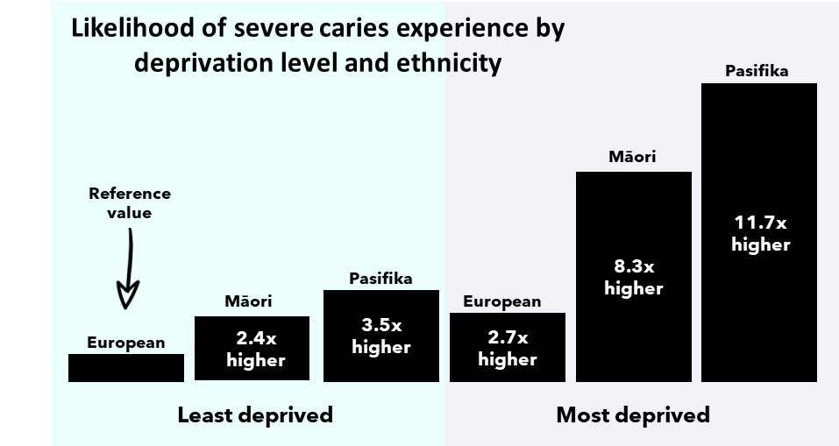
Figure 6 Adjusted odds ratios from the final multivariable model of severe caries experience reported in Schluter and Mattingley 2020

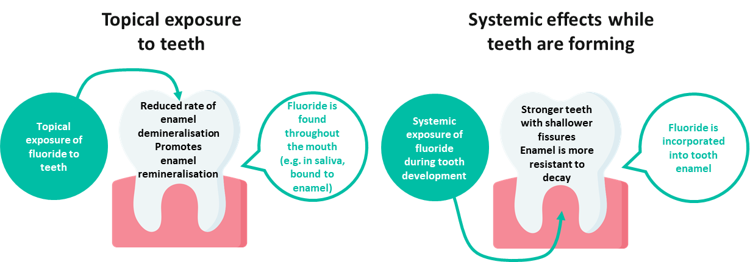
Figure 8 Illustrative figure of how fluoride impacts teeth
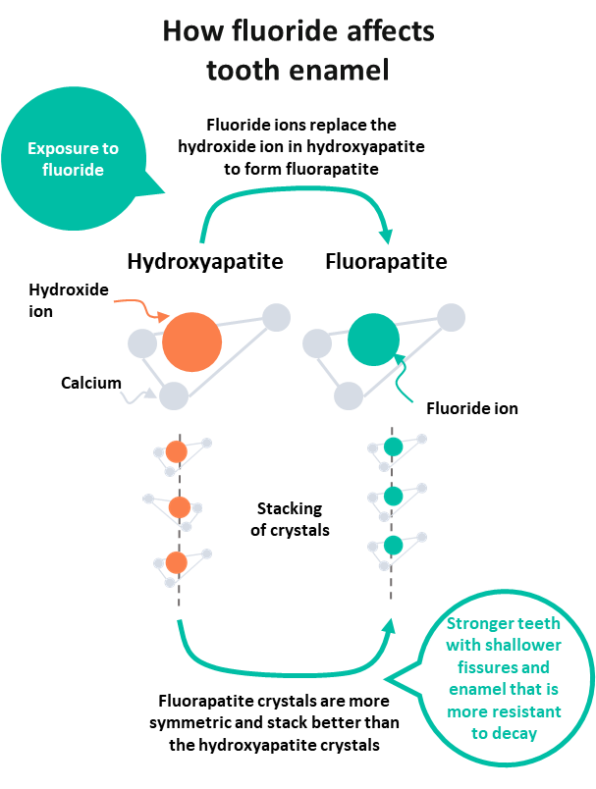
Figure 7 Illustrative figure of how fluoride affects tooth enamel.

Figure 9 An example of mild dental fluorosis (CC BY-NC-ND 4.0) from Cavalheiro et al. 2017
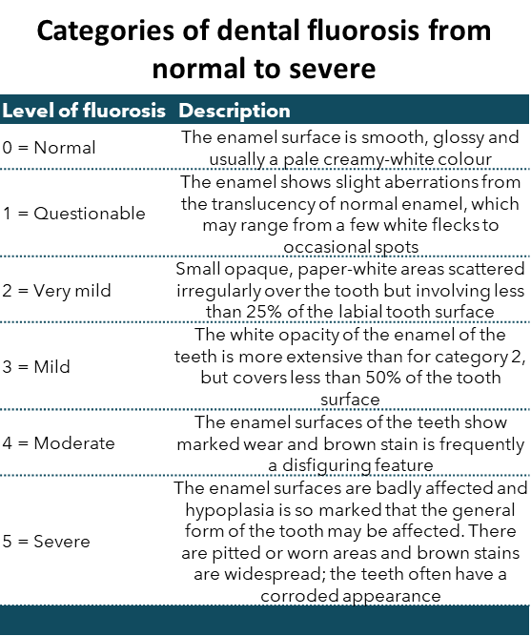
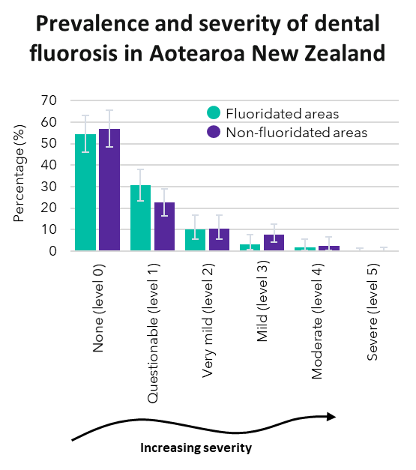
Figure 10 Categories of dental fluorosis used in the 2009 New Zealand Oral Health Survey (see methodology report)
Figure 11 Prevalence and severity of dental fluorosis in Aotearoa New Zealand in 2009 (see 2009 New Zealand Oral Health Survey).
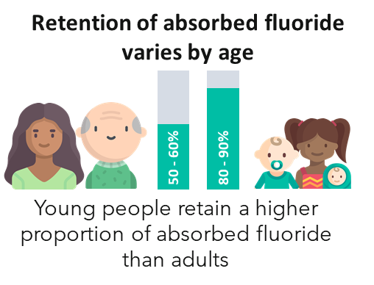
Figure 12 Retention of absorbed fluoride in adults and infants. See WHO

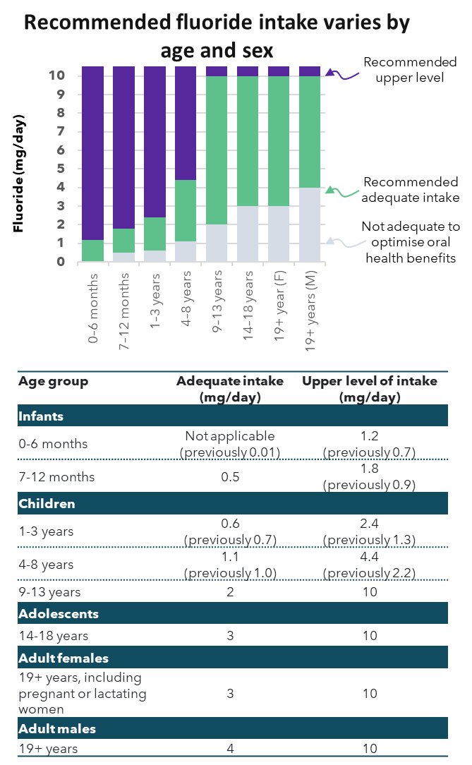
Figure 13 The recommended fluoride intake in Aotearoa New Zealand varies by age and sex. See Nutrient Reference Values set by the Australian and New Zealand Governments.

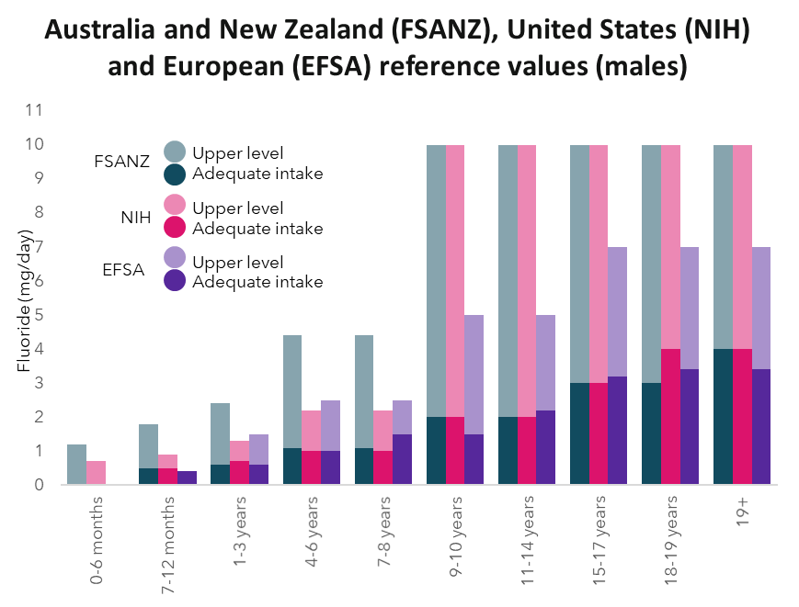
Figure 14 Reference values for males in Australia and New Zealand, the United States and Europe
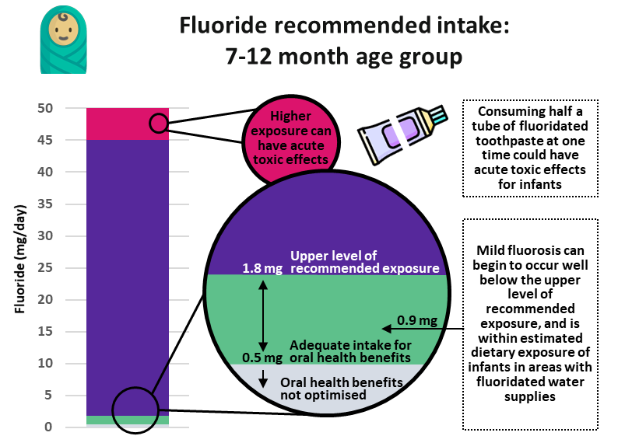
Figure 15 Recommended fluoride intake levels for infants aged 7-12 months old

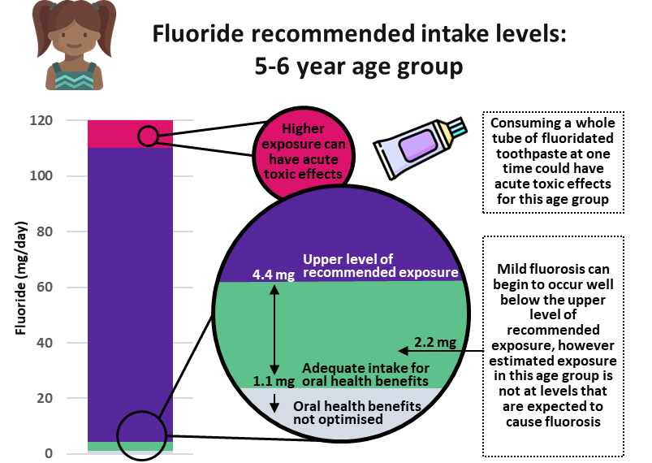
Figure 16 Recommended fluoride intake levels for children aged 5 to 6 years old

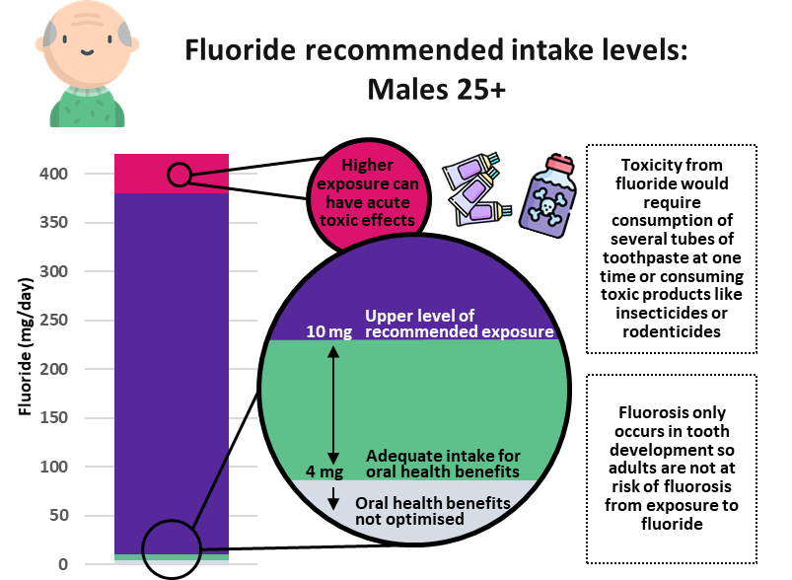
Figure 17 Recommended fluoride intake levels for males over 25 years old
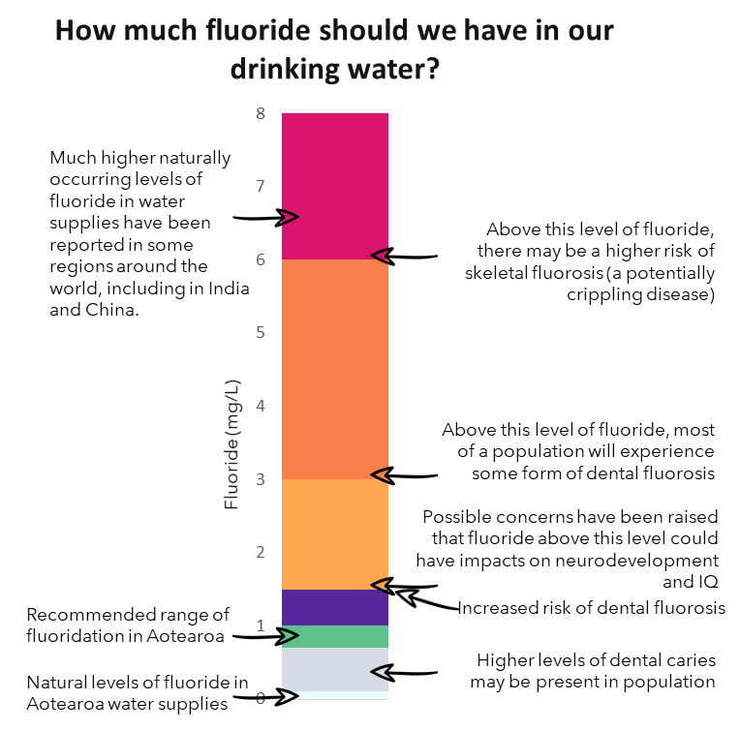
Figure 18 Concentration of fluoride in water and the potential impacts this can have on health
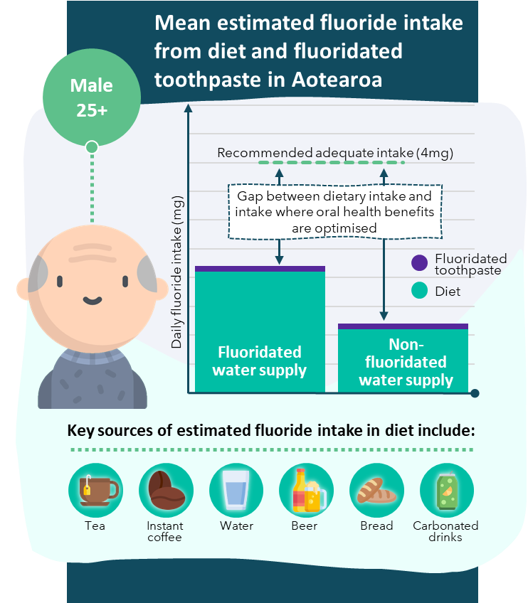
Figure 19 Mean estimated dietary fluoride intake from diet and fluoridated toothpaste in Aotearoa New Zealand for men aged over 25 years old. Data drawn on from Cressey et al.
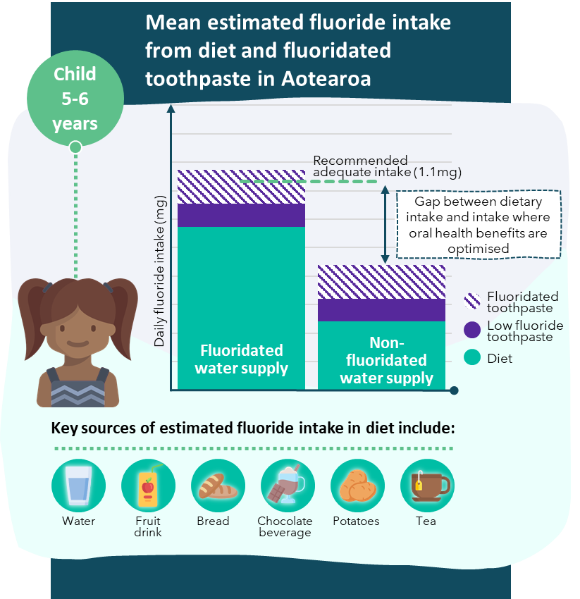
Figure 20 Mean estimated dietary fluoride intake from diet and fluoridated toothpaste in Aotearoa New Zealand for children 5-6 years old. Data drawn on from Cressey et al.

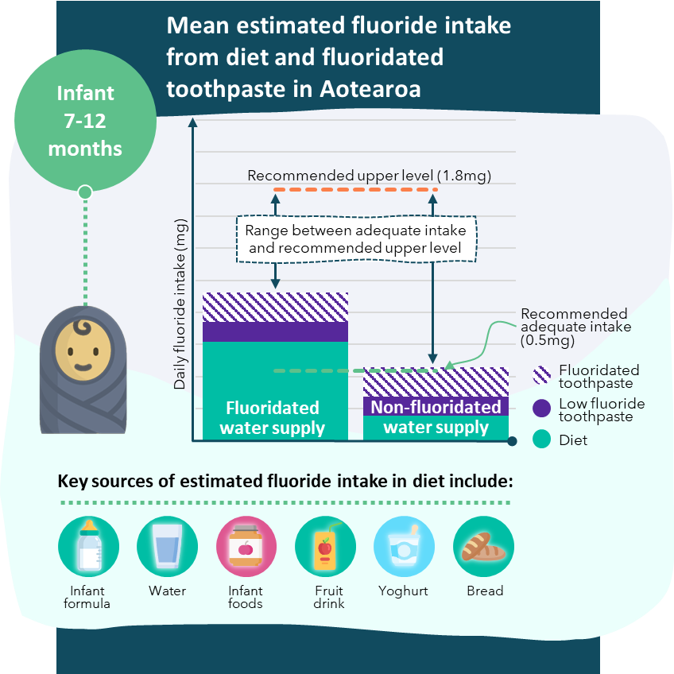
Figure 21 Mean estimated dietary fluoride intake from diet and fluoridated toothpaste in Aotearoa New Zealand for infants 7-12 months old. Data drawn on from Cressey et al.

Aung et al., "Dental Caries and Previous Hospitalisations among Preschool Children: Findings from a Population-Based Study in New Zealand," New Zealand Medical Journal 132, no. 1493 (2019)
Johnston et al., "Principles of Fluoride Toxicity and the Cellular Response: A Review," Archives of Toxicology 94, no. 4 (2020)
Kimambo et al., "Fluoride Occurrence in Groundwater Systems at Global Scale and Status of Defluoridation – State of the Art," Groundwater for Sustainable Development 9 (2019)
Moore et al., "The Costs and Benefits of Water Fluoridation in Nz," BMC Oral Health 17, no. 1 (2017)
Schluter et al., "Association between Community Water Fluoridation and Severe Dental Caries Experience in 4-Year-Old New Zealand Children," JAMA Pediatrics 174, no. 10 (2020)

